Pratical No : 1
Aim: Use Google and Whois for Reconnaissance
(1)Go to link https://who.is/ you will be redirected to the page as shown below
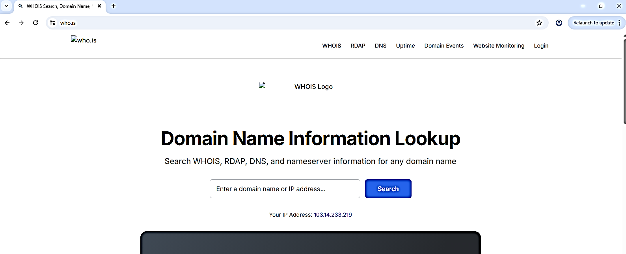
(2)
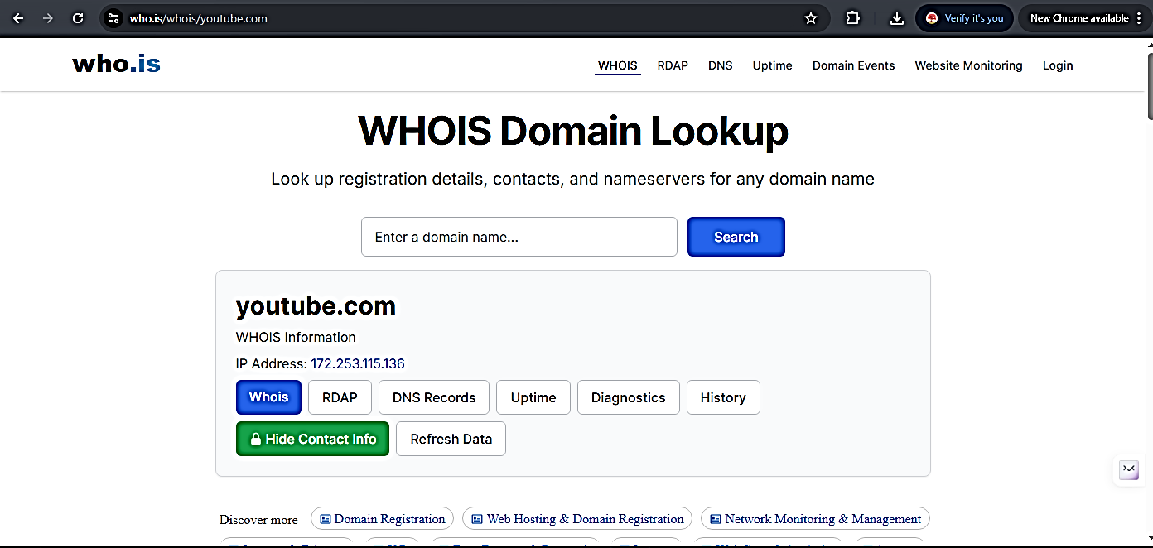

Method 2:
Step 1 : download who is
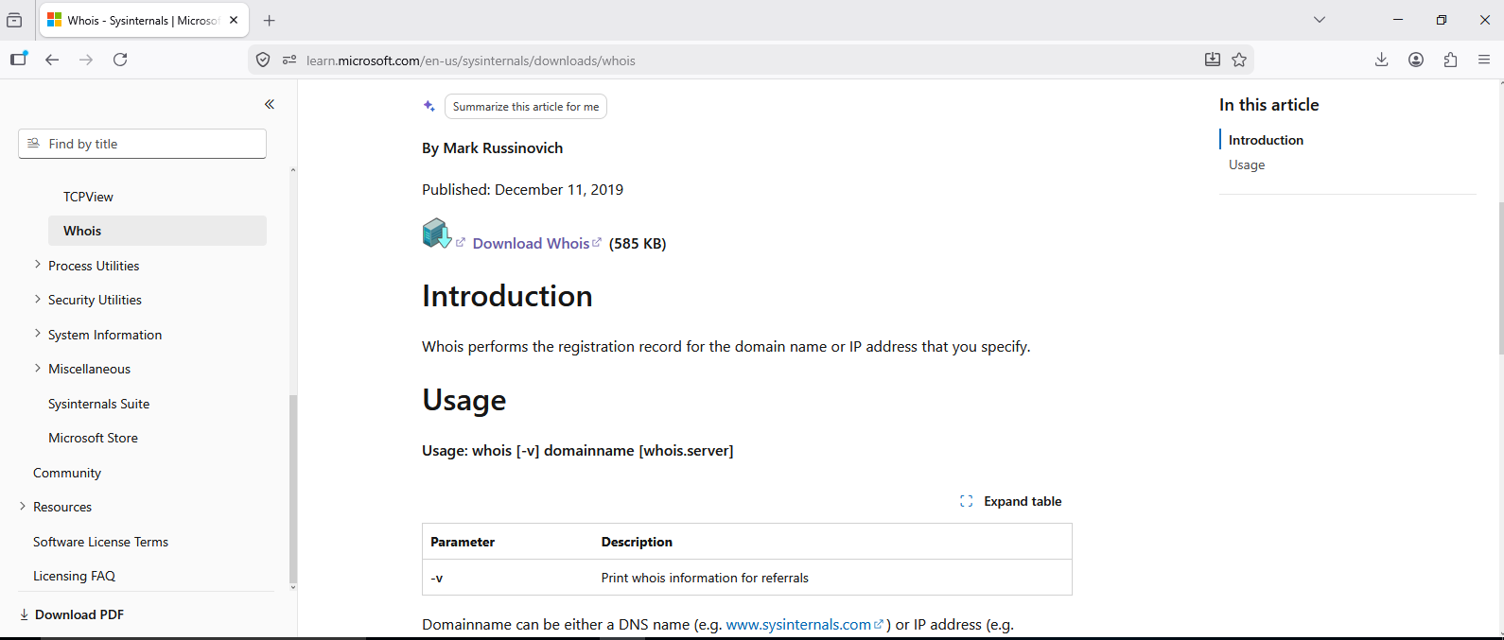
Step 2: Extract file withy PATH
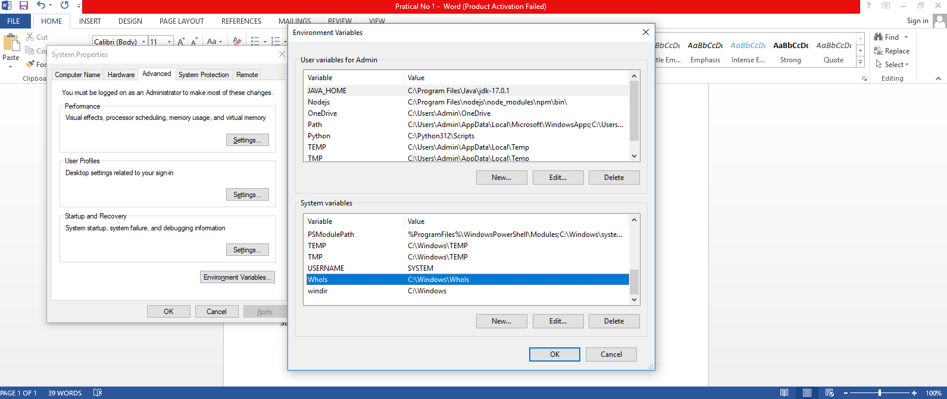
CLICK OK
Step 4: go to cmd prompt
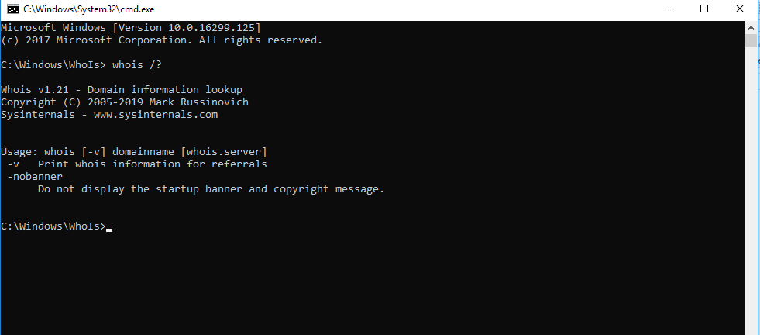
Step 5 : type the cmd to the collect the info about website : whois website_name
